**Financial Portfolios Tracking System**

Design Documentation  
Prepared by <TEAM>:

* Mitchell Derby
* Pedro Vega
* Beltran Caliz
* Quang Vu

**Index**

Summary…………………………………………………………………………………………. 1

Requirements 2

Domain Model 3

System Architecture 4

Subsystems 5

Subsystem #1 6

Subsystem #2 7

Sequence Diagrams 8

Appendix 9

**Summary**

This section provides a brief overview of the project.

* Describe your high-level architectural, i.e. subsystem, design.
* Give a rationale for the major design choices
* Tie back to specific requirements statements
* Outline how the design reflects a balance among competing design principles such as low coupling and etc

**Domain Model**

This section provides a domain model for the project. It should follow the guidelines discussed in class and the design project activity sheets.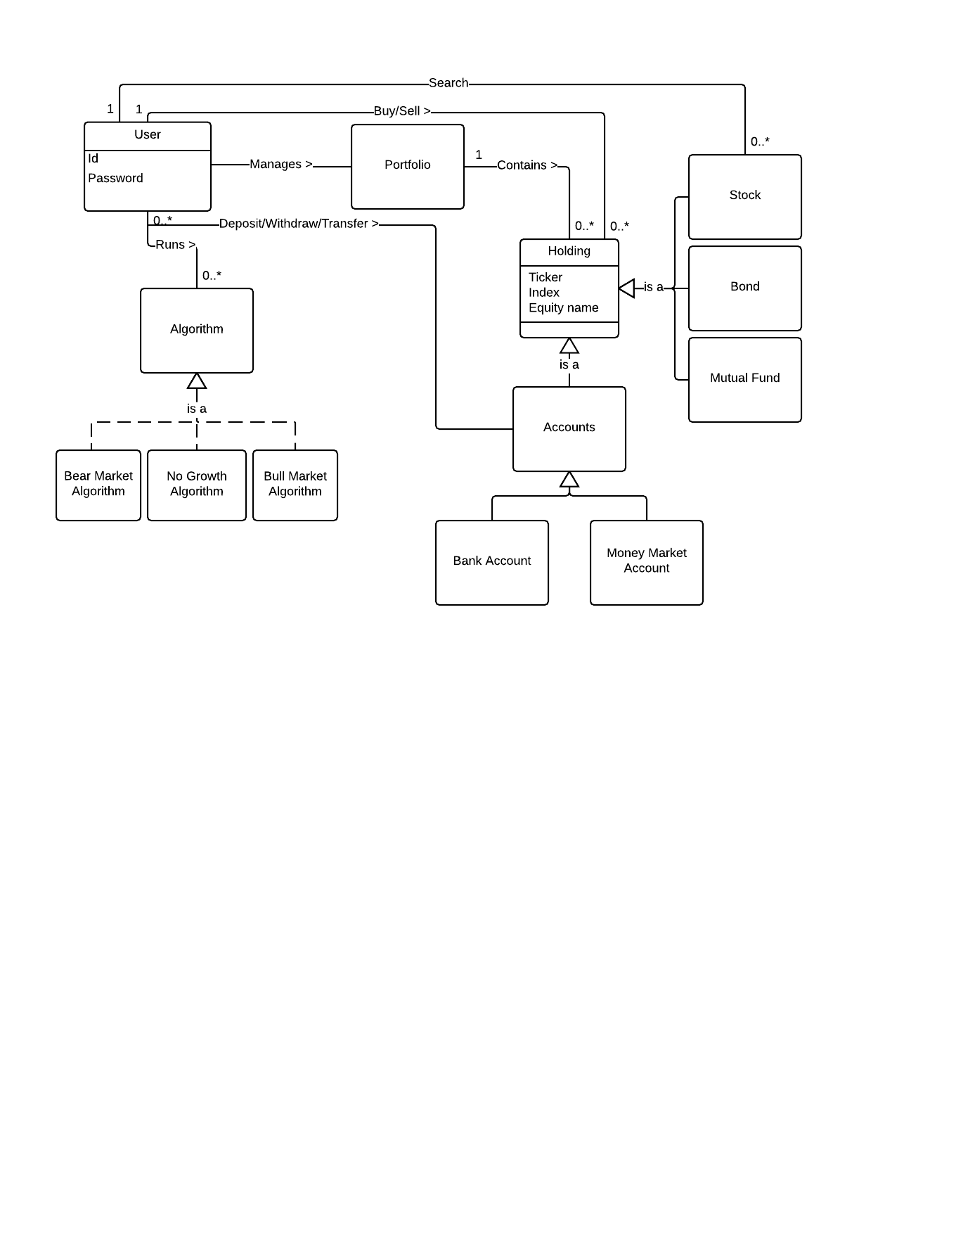

**UML class diagrams**

* We may need to divide the class diagram to multiple class diagram

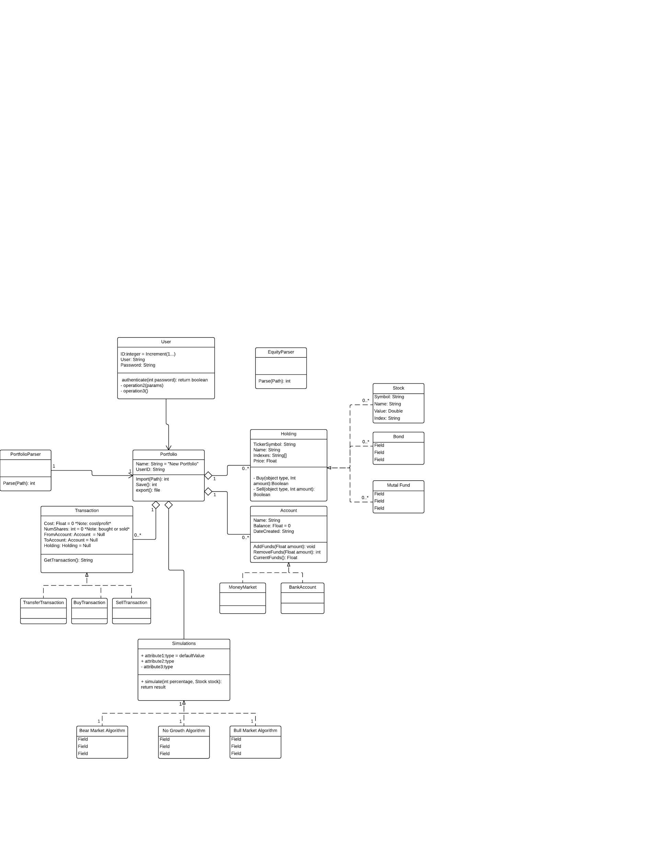

**Class-Responsibilities-Collaborators**

|  |  |
| --- | --- |
| **Class:** |  |
| **Responsibilities:** | |
| **Collaborators** | |
| **Uses:** | **Used by:** |
| **Author:** | |

**Patterns**

1. Descriptive name within the context of the application
2. Identify each class role in the patterns. The class names themselves should reflect the class’ contributions in the context of the application and must not be simply the class names from the pattern structure.
3. Describe in the context of the application what each participant contributes, do not simply repeat the responsibilities of the class’ participant in the pattern description.
4. Describe the requirements of the system that the pattern is covering.

|  |  |  |  |
| --- | --- | --- | --- |
| **Name:** | | | **GoF pattern:** |
| **Participants** | | | |
| **Class** | **Role in pattern** | **Participant's contribution in the context of the application** | |
|  |  |  | |
|  |  |  | |
|  |  |  | |
| **Deviations from the standard pattern:** | | | |
| **Requirements being covered:** | | | |

**Sequence Diagrams**

This section contains the sequence diagrams and narrative text that describe the operation of major features in the application. At a minimum, you should document any features that are listed in the design project problem statement. You may also decide that other features require documentation.

The sequence diagrams for at least two non-trivial features in the implementation. Check the problem statement for the features to diagram. If none are provided in the problem statement, then the team is to select the two features that provide the most insight into significant features of the system. Rarely will your sequence diagrams be able to stand alone. You will need to provide accompanying text to aid the reader in understanding the operation of the feature. It is strongly encouraged that you make this part of your narrative.